## BIOLOGY I CORNELL

**LS-H-B3: \*** Analyze pedigrees to identify patterns of inheritance for common genetic disorders * Calculate the probability of genotypes and phenotypes of offspring given the parental genotypes

## NOTES

|  |  |  |  |
| --- | --- | --- | --- |
| **Unit 4: Genetics & Heredity**  **Ch. 11.1 – 3 (p.306 – 322):** Gregor Mendel, Punnett Squares, & Patterns of Inheritance | | | Name: |
| Date: |
| Period: |
| **Vocabulary** | **Definition** | | **How I will remember it:** |
| **Genetics** | The scientific study of heredity & how characteristics are passed from parent to offspring | |  |
| **Fertilization** | The fusion of a haploid sperm cell and haploid egg cell to form a diploid zygote | |  |
| **Trait** | A specific characteristic of an individual, such as color or height | |  |
| **Hybrids** | Offspring of crosses between parents with different traits | |  |
| **Genes** | Factors that are passed from parent to offspring which determine an individual’s traits; sections of DNA that control traits | |  |
| **Alleles** | Different forms or variations of a gene | |  |
| **Principle of Dominance** | Mendel’s statement that some alleles are dominant and others are recessive – dominant alleles will “cover up” recessive alleles | |  |
| **Segregation** | The separation of alleles during the formation of gametes in meiosis | |  |
| **Section 11.1 – The Work of Gregor Mendel** | | | |
| **Questions/Main Ideas/Vocabulary** | **Notes/Answers/Definitions/Examples/Sentences** | | |
| *Who was Gregor Mendel?* |  | | |
| Image result for mendel's peas | | | |
| **Questions/Main Ideas/Vocabulary** | **Notes/Answers/Definitions/Examples/Sentences** | | |
| *Mendel’s Pea Plant Experiments* |  | | |
| *Mendel’s Conclusions* |  | | |
|  | | |
|  | | |
|  | | |
|  | | |
|  | | |
| *Mendel’s Principles of Inheritance* |  | | |
|  | | |
|  | | |
|  | | |
|  | | |
|  | | |
|  | | |
|  | | |
| **Section 11.2 – Applying Mendel’s Principles (Punnett Squares)** | | | |
| **Questions/Main Ideas/Vocabulary** | **Notes/Answers/Definitions/Examples/Sentences** | | |
| *Using a Punnett Square* | 1.  2.  3. | | |
| *Example Cross:* | |  |  | | --- | --- | |  |  | |  |  | | | |
| *Example Cross:* | |  |  | | --- | --- | |  |  | |  |  | | | |
| **Vocabulary** | **Definition** | **How I will remember it:** | |
| **Probability** | Likelihood that a particular event will occur |  | |
| **Homozygous** | Organisms that have two identical alleles for a particular trait (RR or rr) |  | |
| **Heterozygous** | Organisms that have two different alleles for a particular trait (Rr) |  | |
| **Phenotype** | Physical traits; how a gene is expressed |  | |
| **Genotype** | Genetic makeup of a trait |  | |
| **Codominance** | Occurs when 2 or more alleles are dominant, and heterozygotes express both traits equally without any blending. |  | |

|  |  |  |
| --- | --- | --- |
|  | | |
| ***Example Cross:*** | |  |  | | --- | --- | |  |  | |  |  | | |
| **Vocabulary** | **Definition** | **How I will remember it:** |
| **Incomplete Dominance** | Occurs when the phenotype of the heterozygous genotype is distinct from and often intermediate to the phenotypes of the homozygous genotypes. |  |
|  | | |
| *Example Cross:* | |  |  | | --- | --- | |  |  | |  |  | | |
| **Questions/Main Ideas/Vocabulary** | **Notes/Answers/Definitions/Examples/Sentences** | |
| *What is the difference between codominance & incomplete dominance?* |  | |
| **Vocabulary** | **Definition** | **How I will remember it:** |
| **Epistasis** | Occurs when an allele from one gene counteracts or stops another gene controlling the same trait. |  |
|  | | |
| *Example Cross:* | |  |  |  |  | | --- | --- | --- | --- | |  |  |  |  | |  |  |  |  | |  |  |  |  | |  |  |  |  | | |
| **Vocabulary** | **Definition** | **How I will remember it:** |
| **Sex-Linked Gene** | Genes that are carried by either sex chromosome (X or Y in humans). |  |
| *Example Cross:* | |  |  | | --- | --- | |  |  | |  |  | | |
| **Vocabulary** | **Definition** | **How I will remember it:** |
| **Polygenic Inheritance** | Occurs when one characteristic is controlled by two or more genes. Often the genes are large in quantity but small in effect. |  |
|  | | |
| *Could 2 light-skinned people have a baby with darker skin than either parent?* |  | |

|  |  |  |  |  |
| --- | --- | --- | --- | --- |
| **Unit 4: Genetics & Heredity**  **Ch. 14.1 (p.390-397) Human Heredity** | | | Name: | |
| Date: | Blk: |
| **Vocabulary** | **Definition** | | **How I will remember it:** | |
| **Pedigree** | A chart that shows the presence or absence of a trait according to the relationships among parents, siblings, and offspring. | |  | |
| Image result for pedigree | | | | |
| **Example** | | | | |
| Image result for pedigree | | **1.** Is retinoblastoma caused by a dominant or recessive mutation? | | |
|  | | |
| **2.** Is retinoblastoma a sex-linked trait? | | |
|  | | |
| **3.** Is retinoblastoma a deadly form of cancer? | | |
|  | | |
| Complete the probable pedigree if the affected daughter in Generation III has four children with a normal man.  Image result for pedigreeImage result for pedigree | | | | |

* Use the colors provided on the Station Marker!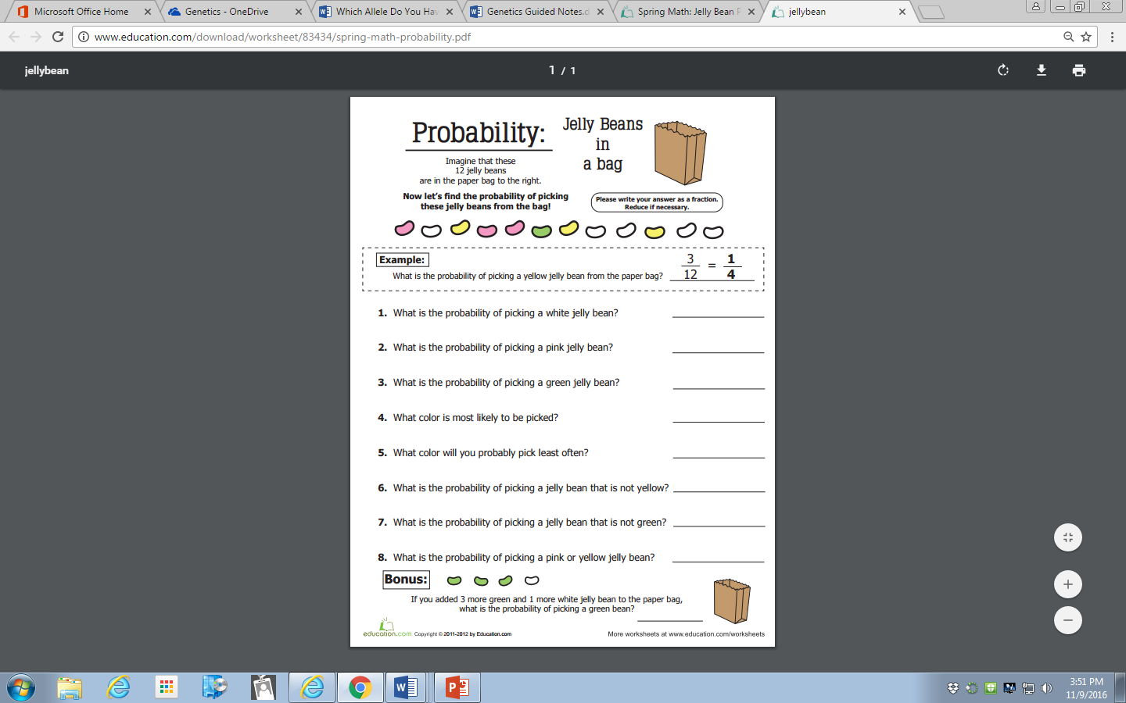

Station 1

*Which Alleles Do You Have?* Date: _____________ Block: ____

Station 2

**Directions:** An “**allele**” is a variation of a gene. Traits and alleles can be dominant or recessive. **Recessive** traits only show up if two recessive alleles make up the gene. A **dominant** allele will cover up the recessive allele. In the table below, each partner should determine whether they have the dominant trait or the recessive trait. Then circle all possible genotypes in the space below their name. For example, if partner 1 has curly hair, he/she would circle “CC” & “Cc” in the space next to *Hair Type*; and if partner 2 has straight hair, he/she would *only* circle “cc.”

|  |  |  |
| --- | --- | --- |
| **Partner 1 Name:** | **Trait**  **Dominant Allele Recessive Allele** | **Partner 2 Name:** |
| BB Bb bb | *B Eye Color b*  Brown Blue/green/hazel/gray | BB Bb bb |
| DD Dd dd | *D Hair Color d*  Dark Light / red | DD Dd dd |
| CC Cc cc | *C Hair Type c*  Curly Straight | CC Cc cc |
| WW Ww ww | *W Hairline w*  Widow’s Peak Smooth | WW Ww ww |
| DD Dd dd | *D Facial Features d*  Dimples No dimples | DD Dd dd |
| FF Ff ff | *F f*  Freckles No freckles | FF Ff ff |
| BB Bb bb | *B b*  Broad lips Thin lips | BB Bb bb |
| WW Ww ww | *W w*  Wide nose Narrow nose | WW Ww ww |
| SS Ss ss | *S s*  Smooth chin Cleft chin | SS Ss ss |
| UU Uu uu | *U Earlobes u*  Unattached Attached | UU Uu uu |
| DD Dd dd | *D Joints d*  Double-jointed Normal joints | DD Dd dd |
| RR Rr rr | *R Handedness r*  Right-handed Left-handed | RR Rr rr |
| HH Hh hh | *H Knuckles h*  Hairy Bare | HH Hh hh |
| TT Tt tt | *T Tongue-rolling t*  Can roll tongue Cannot roll tongue | TT Tt tt |

Name: _________________________________________ Block: _____ Date: _________

**Genetics Practice Problems**

Station 3

An individual is said to be either homozygous for a trait or heterozygous for the trait. A **homozygous** individual has two copies of an allele (RR or rr). A **heterozygous** individual has one copy of each allele (Rr).

1. For each genotype, indicate whether it is heterozygous (HE) or homozygous (HO). (1pt)

|  |  |  |  |
| --- | --- | --- | --- |
| AA ____ Bb ____ Cc ____ Dd ____ | Ee ____ ff ____ GG ____  HH ____ | Ii ____ Jj ____ kk ____ Ll ____ | Mm ____ nn ____ OO ____ Pp ____ |

2. For each of the genotypes below, determine the phenotype. (2 pts)

|  |  |
| --- | --- |
| *Purple flowers are dominant to white flowers* PP ___________________________ Pp ___________________________ pp ___________________________ | *Brown eyes are dominant to blue eyes* BB ___________________________ Bb ___________________________ bb ___________________________ |
| *Round seeds are dominant to wrinkled* RR ___________________________ Rr ___________________________ rr ___________________________ | *Bobtails are recessive (long tails dominant)* TT ___________________________ Tt ___________________________ tt ___________________________ |

3. For each phenotype, list the genotypes. (Hint: use the letter of the dominant trait). (2 pts)

|  |  |
| --- | --- |
| *Straight fur is dominant to curly.* ____________ straight ____________ straight ____________ curly | *Pointed heads are dominant to round heads.* ____________ pointed ____________ pointed ____________ round |

4. Set up the Punnett Square for each of the crosses listed below. The trait being studied is round seeds (dominant) and wrinkled seeds (recessive). (4 pts each)

**Rr x rr** 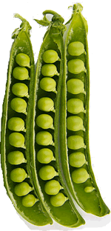

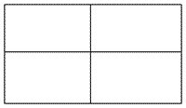

What percentage of the offspring will be round? _______

Set up the Punnett Square for each of the crosses listed below. The trait being studied is round seeds (dominant) and wrinkled seeds (recessive). (4 pts each)

Station 4

**Rr x R r** 



What percentage of the offspring will be round? _______

**RR x Rr**



What percentage of the offspring will be round? ___________

**Practice with Crosses. Show all work! Draw the Punnett Square! (3 pts each)**

5. A TT (tall) plant is crossed with a tt (short plant).   
     What percentage of the offspring will be tall? ___________

6. A Tt plant is crossed with a Tt plant.   
    What percentage of the offspring will be short? ______

7. A heterozygous round seeded plant (Rr) is crossed with a  
homozygous round seeded plant (RR).   
What percentage of the offspring will be homozygous (RR)? ________

8. A homozygous round seeded plant is crossed with a homozygous   
wrinkled seeded plant.

What are the genotypes of the parents? _____ x _____

What percentage of the offspring will also be homozygous? _______

9. In pea plants purple flowers (P) are dominant to white flowers (p).   
If two white flowered plants are crossed, what percentage of their   
offspring will be white flowered? _________

10. A white flowered plant is crossed with a plant that is   
heterozygous for the trait.

What percentage of the offspring will have purple flowers? ______

11. Two plants, both heterozygous for the gene that controls  
flower color are crossed.

What percentage of their offspring will have purple flowers? _______  
What percentage will have white flowers? ______

12. In guinea pigs, the allele for short hair is dominant.

What genotype would a heterozygous short haired guinea pig have? _______  
What genotype would a long haired guinea pig have? ________

13. Show the cross for a pure breeding short haired guinea pig  
and a long haired guinea pig.  
What percentage of the offspring will have short hair? __________

14. Two short haired guinea pigs are mated several times. Out of 100  
offspring, 25 of them have long hair. What are the probable  
genotypes of the parents? ________ x _______

Dihybrid Crosses

**STEP 1:** Determine what kind of problem you are trying to solve.

**STEP 2:** Determine letters you will use to specify traits.

**STEP 3:** Determine parent’s genotypes.

**STEP 4:** Make your punnett square and make gametes

**STEP 5:** Complete cross and determine possible offspring.

**STEP 6:** Determine genotypic and phenotypic ratios.

**Two-Factor Crosses (Di-hybrid)**

1. A tall green pea plant (TTGg) is crossed with a tall green pea plant (TtGg)

___________ X ___________

|  |  |  |  |
| --- | --- | --- | --- |
|  |  |  |  |
|  |  |  |  |
|  |  |  |  |
|  |  |  |  |

Tall/Green: ____ Tall/White : ____ Short/Green : ____ Short/ White: _____

1. A tall green pea plant (TtGg) is crossed with a Short white pea plant (ttgg).

___________ X ___________

|  |  |  |  |
| --- | --- | --- | --- |
|  |  |  |  |
|  |  |  |  |
|  |  |  |  |
|  |  |  |  |

Tall/Green: ____ Tall/white: ____ short/Green: ____ short/ white: _____

1. A Homozygous tall, green flowered plant is crossed with a homozygous short white flowered plant.

___________ X ___________

|  |  |  |  |
| --- | --- | --- | --- |
|  |  |  |  |
|  |  |  |  |
|  |  |  |  |
|  |  |  |  |

Tall/green: ____ Tall/White: ____ Short/green: ____ Short/White: ____

**Directions:** complete the following dihybrid crosses. **Hint:** make yourself a key of which genotypes produce each phenotype. Reduce all ratios.

1. In peas, tall (T) is dominant to short (t), and green (G) is dominant to white (g). Show dihybrid Punnett Square if two Heterozygous Tall, Green pea plants are crossed.

___________ X ___________

|  |  |  |  |
| --- | --- | --- | --- |
|  |  |  |  |
|  |  |  |  |
|  |  |  |  |
|  |  |  |  |

Tall/Green: ____ Tall/White: ____ Short/Green: ____ Short/ White: ____

1. In cattle, assume that spotted skin (N) is dominant over non-spotted skin (n) and that wooly hair (H) is dominant over non-wooly hair (h). Cross a heterozygous spotted, non-wooly bull with a heterozygous wooly-haired, non-spotted cow. Give genotypic and phenotypic ratios of offspring.

___________ X ___________

|  |  |  |  |
| --- | --- | --- | --- |
|  |  |  |  |
|  |  |  |  |
|  |  |  |  |
|  |  |  |  |

Spotted/Wooly: _____ Spotted/non-wooly: _____ non-spotted/Wooly: _____ non-spotted/non-wooly: ____

2. In horses, black hair is a dominant gene, B, and **chestnut\*** hair is recessive, b. The trotting gait is due to a dominant gene, T, the pacing gait to its recessive allele, t. If a homozygous black pacer is mated to a homozygous chestnut trotter, what will be the genotypes & phenotypes of the F1 generation?

___________ X ___________

|  |  |  |  |
| --- | --- | --- | --- |
|  |  |  |  |
|  |  |  |  |
|  |  |  |  |
|  |  |  |  |

Black/Trotter: _____ Black/pacer: _____ chestnut/Trotter: _____ chestnut/pacer: ____

**\*chestnut** = reddish-brown; also called “russet” like potatoes and birds

3. In summer squash, white fruit color (W) is dominant over yellow fruit color (w) and disk-shaped fruit (D) is dominant over sphere-shaped fruit (d). If a squash plant true-breeding for white, disk-shaped fruit is crossed with a plant true-breeding for yellow, sphere-shaped fruit, what will be the genotypes & phenotypes of the F1 generation?

___________ X ___________

|  |  |  |  |
| --- | --- | --- | --- |
|  |  |  |  |
|  |  |  |  |
|  |  |  |  |
|  |  |  |  |

White/Disk: _____ White/sphere: _____ yellow/Disk: _____ yellow/sphere: ____

Name: ____________________________________ __ Date: _____________ Block: _____

**Family History – Personal Pedigree Project**

**Directions:** Draw your family tree! Track the presence of a specific trait (such as dimples, freckles, attached earlobes, widow’s peak, tongue-rolling, etc.) through 3 generations. You must include your parents, you and any siblings you have, and your grandparents OR any nieces/nephews you may have. Include a key that explains each symbol used (identify male/female, affected/unaffected, and possible carriers). Use p. 397.