**The Natural Selection of Froot Loops: An Evolutionary Investigation**

*Essential Question: How do mimicry and protective coloration evolve?*

*Background Research:*

One of the most noticeable forms of environmental pressure is **predation**.

Predators eat other organisms, while prey are eaten by them. We will

study the evolution of **protective coloration**. Many animals use

camouflage to avoid being seen by their predators. Some prey will mimic

part of their habitat, or even another species.

**Procedure:**  
1. Each pair of students will begin with a different color of  
"environment" (construction paper). Pick one person to be the  
“Froot Loop Predator”. (You will swap roles later). The predator

should not look at what the other person does in Step 2.  
2. The other person randomly scatters four (4) of each color of  
loops on the environment. Record these numbers on your data

table under Generation 1.  
3. The Froot Loop Predator should now capture ten (10) wild Froot  
Loops in order to survive. Look away from the environment, look

back quickly, and grab the first one you see. Then look away again

until you select the next one. **Don’t waste precious predator time**

**being picky! Grab the first fruit loop you see and eat it!**  
4. The Froot Loops that you ate died (they don’t get to reproduce).  
The ones left on your environment survived! Each surviving Froot

Loop reproduces. Add one more of that color (example: if 3 reds

survive, add 3 more red Froot Loops).  
5. Count your Froot Loops and record the number of each color  
variety for Generation 2. (Always = 20)  
6. Switch roles!

7. Repeat Steps 3 through Step 5 for Generations 3 – 6.

Name: ___________________________ Date: __________ Block: ____

**Data Collection:**

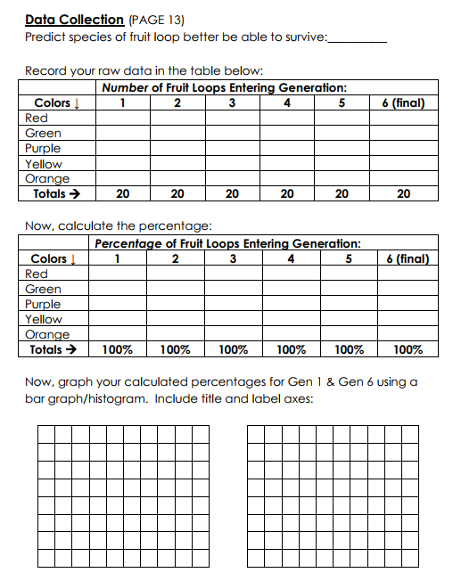

**Analysis Questions:**

1. Refer to your simulation.

a. What color was your “habitat?” ________________

b. Which color Froot Loop made up the largest portion of the

population by the end of the simulation? ________________

c. Propose a conclusion (an answer to our essential question).

How did camouflage evolve in this Froot Loop population?

_______________________________________________________

_______________________________________________________

_______________________________________________________

2. Using the results of this lab, consider the following scenarios:  
 a. If the color differences were less distinct (ex. All loops were only

shades of reds and oranges), would you expect similar results?

Explain what you would expect and why.

_______________________________________________________

_______________________________________________________

_______________________________________________________

b. What if you had a population with all 5 colors again, but the

red Froot Loops made the predator very sick; would you expect similar results? Explain what you would expect and why.

_______________________________________________________

_______________________________________________________

_______________________________________________________

c. Over the long term, what trait (ability) could be strongly  
 selected for in the predator population in the situation of

similar color variants proposed above?

_______________________________________________________

_______________________________________________________

_______________________________________________________

3. Consider the results of this lab.  
 a. Did any of the fruit loops survive because they **chose** to  
 be a certain color? ___________  
 b. Did any “supernatural power” design the surviving Froot   
 Loops to be more likely to survive? ______________  
 c. What **caused** your Froot Loop population to change over the

six generations?

_______________________________________________________

_______________________________________________________

_______________________________________________________

4. **Bonus**: Tell me about a real-world example of an animal that is specially camouflaged with its environment. Based on the results of this lab, how do you think that species developed this protective coloration?

_______________________________________________________

_______________________________________________________