## BIOLOGY I

**LS-H-A2:** Compare active and passive cellular transport. Analyze the movement of water across a cell membrane in hypotonic, isotonic, and hypertonic solutions

## CORNELL NOTES

|  |  |  |
| --- | --- | --- |
| **Chapter: 7 Cell Structure & Function**  **(p. 190-217)** | | Name: |
| Date: |
| Section: Cell Transport (p. 208-213) | | Period: |
| **Questions/Main Ideas/Vocabulary** | **Notes/Answers/Definitions/Examples/Sentences** | |
| **The Fluid Mosaic Model**  Why do scientists sometimes describe the cell membrane as a “fluid mosaic?” | File:Cell membrane detailed diagram edit2.svg - Wikipedia | |
| **Characteristics of the Phospholipid Bilayer** | **1) Hydrophilic:** | |
|  | |
| **2) Hydrophobic:** | |
|  | |
| **3) Selective Permeability:** | | |
|  | | |
|  | | |
| **Vocabulary – Passive Transport** | | |
| **Passive Transport** |  | |
| **Facilitated Diffusion** |  | |
| **Osmosis** |  | |
| **Aquaporin** | Water channel protein in the cell membrane that allows water molecules to avoid the hydrophobic inner membrane, and pass through | |
| **Osmotic Pressure** | The force of the net movement of water into or out of the cell | |
| **Interpreting Images: How is passive transport different from active transport?passivetransport.jpg** | | |
| **Vocabulary – Simple Solutions** | | |
| **Solution** | a liquid mixture in which the minor component (the solute) is uniformly distributed within the major component (the solvent | |
|  | substance (usually solid) that is being dissolved | |
|  | liquid (usually water) that is doing the dissolving | |

|  |  |
| --- | --- |
| **Types of solutions** | **Hypertonic:** |
| **Isotonic:** |
| **Hypotonic:** |
| **Above each image** of a blood cell undergoing osmosis**, label** each solution around the blood cell as*isotonic, hypertonic, or hypotonic*. **Below each image,** explain how the water is moving. | |

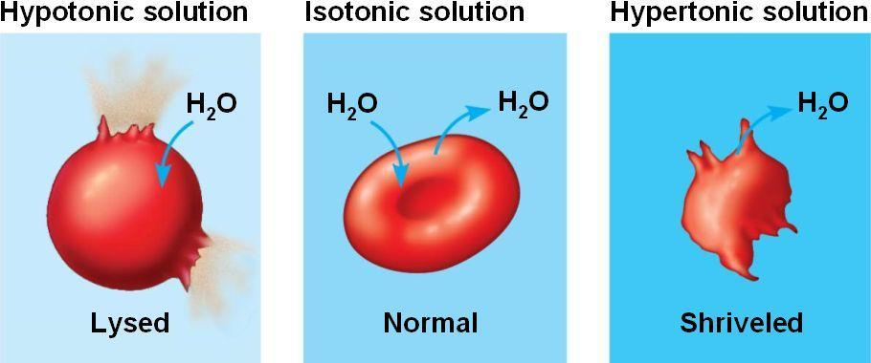

|  |  |  |
| --- | --- | --- |
| **Vocabulary – Active Transport** | | |
| **Active Transport** |  | |
| **Co-Transport** |  | |
|  | The process of taking material *into the cell* by means of infoldings, or pockets, of the cell membrane. | |
|  | “eating” or engulfing large particles | |
|  | “drinking” dissolved substances | |
|  | The process by which materials are expelled, or *sent out of the cell*, by the membrane of a vacuole fusing with the cell membrane and pushing its contents out. | |
| As previously discussed, active and passive transport occur across the cell’s selectively permeable membrane. Below, compare and contrast Active & Passive Transport. | | |
|  | **Passive Transport** | **Active Transport** |
| **Definition:** |  |  |
| **Example:** |  |  |
| **Direction:**  (with or against the concentration gradient?) |  |  |
| **Requires Energy (ATP)?** |  |  |
| ***Study Tips*** | | |
| *Look back at the definition for “phagocytosis.” What does the prefix “phago” mean?* |  | |
| *Look at the definition for “pinocytosis.” What does the prefix “pino” mean?* |  | |
| *Based on the meanings of hypertonic, isotonic, and hypotonic, define the prefixes “hyper,” “hypo,” and “iso.”* ***Give an example of each being used in another word.*** | Hyper =  Hypo =  Iso = | |