**EOC Mini Stations**

1. Cell organelles
   1. Materials:
      1. Large posters w/ plant cell & animal cell drawings
      2. Laminated organelle cards w/ velcro backing
   2. Before Class
      1. Draw & laminate plant cell & animal cell outlines on large posters
      2. Attach velcro to organelles:
         1. Nucleus (2)
         2. Nucleolus (2)
         3. Rough ER (2)
         4. Smoot ER (2)
         5. Mitochondria (2)
         6. Chloroplast (1)
         7. Central vacuole (1)
         8. Centrioles (1)
         9. Microtubules (2)
         10. Ribosome (2)
         11. Cell membrane (2)
         12. Cell wall (1)
      3. Write & laminate organelle cards on construction paper
      4. Attach velcro backing
   3. Students:
      1. Use organelle cards to label the plant cell & animal cell. Some cards will only be placed on either the plant or the animal cell
      2. Get checked by teacher.
2. Stages of Mitosis
   1. Materials:
      1. Laminated printouts of cells in stages of mitosis
         1. Interphase
         2. Prophase
         3. Metaphase
         4. Anaphase
         5. Telophase
         6. Cytokinesis
      2. Laminated cards w/ names of stages
      3. Laminated descriptions of mitosis & meiosis
   2. Before Class:
      1. Set up station with deck of stage cards & deck of name cards
      2. Create T-chart / Venn Diagram of tape
   3. Students:
      1. Arrange pictures of cells in correct order
      2. Label stages with name cards
      3. Complete the Tchart by placing each description under mitosis or meiosis
      4. Get checked by teacher
3. Food Web
   1. Materials:
      1. Ecosystem description card
      2. Organism cards (laminated)
      3. Dry erase markers
   2. Before Class:
      1. Attach description card to table
      2. Deck of organism cards (identified by color)
   3. Students:
      1. Based on ecosystem description, arrange organism cards into a food web. Use dry erase markers to draw the arrows to show the relationships among all organisms
      2. Get checked by teacher
      3. Teacher will make one change to ecosystem (add or remove an organism).
      4. Rearrange all the cards to show the effects of this change
      5. Get checked
4. Transcription
   1. Materials:
      1. Individual nucleotides (cut from complete DNA / RNA strand)
   2. Before Class:
      1. Attach one completed *side* of DNA strand to table
      2. Leave all other nucleotides in a pile
   3. Students:
      1. Complete the *complementary side* of the original DNA strand using the correct base pairs (Chargaff’s Rule)
      2. Get checked by teacher
      3. Create the resulting *mRNA* strand from the new DNA strand, using the correct base pairs (which nucleotide is different in RNA)
      4. Get checked by teacher
5. Translation
   1. Materials:
      1. Laminated strand of mRNA (different from #4) made from codon cards
      2. Laminated codon key
      3. Laminated amino acid cards
   2. Before Class:
      1. Attach codon cards in sequence to produce complete mRNA strand (start to stop)
      2. Attach codon key to table
   3. Students
      1. Use codon key to translate each codon within RNA sequence into a word (amino acid)
      2. If correct, should form a real sentence
      3. Get checked by teacher

## Punnett Squares

* 1. Materials:
     1. Genetics problem description (laminated)
     2. Base Punnett Square (strips of tape)
     3. Laminated “A” and “a” cards
  2. Before Class:
     1. Stick problem description onto table
     2. Create base Punnett Square by making a grid using masking tape
     3. Set out pile of A cards & a cards
  3. Students
     1. From the description, place 2 allele cards across the top and 2 allele cards on the side of the Punnett Square to represent the parental genotypes.
     2. Fill in all 4 boxes of the punnett square using the allele cards to show the possible offspring from the cross
     3. use dry erase markers to write out the genotypic ratio (1:2:1 or 25% AA, 50% Aa, 25% aa) and phenotypic ratio (3:1 or 75% sharp, 25% dull)
     4. (optional - teacher decides if group has time) Cross two of the offspring in the F1 generation (inside the punnett square) together. Determine the ratios.
     5. Get checked by teacher

1. LEFTOVER TIME ACTIVITY - If class is on track & might finish rotating through all 6 stations w/ more than 5 minutes left over, begin this class demo after the 4th rotation (to allow time for changes to occur)
   1. Materials
      1. Uncooked eggs (2)
      2. Frying pans (2)
      3. Rubbing alcohol
      4. Water
   2. In Front of Students (Class Demo)
      1. Take two frying pans and place them side by side on a table
      2. Fill one frying pan with water and fill the other with alcohol (approximately 1cm deep in each frying pan)
         1. Student Predictions: I’m putting one egg in a pan of water and one in a pan of rubbing alcohol. There is no heat. Do you think anything is going to happen to either egg?
            1. Build on their ideas for ~1min
      3. Crack an egg into each of the frying pans
         1. Observe how the egg cracked into the alcohol changes in appearance over a period of time (after 5, 10. 30 minutes, 24 hours)
         2. Observe the egg that was cracked into the water and any changes in its appearance
   3. Discussion Questions - after all rotations have been completed. Bring students back around to view changes in the eggs
      1. What is required in order to cook something?

*The definition of cooking is to transform by heating and therefore heat is required to cook.*

* + 1. If alcohol is able to mimic the effect of cooking an egg, what effect do you think it has on your body?

*Exposure to too much alcohol can cause damage to cells in the body.*

* + 1. What effect do you think drinking alcohol would have on an unborn baby?

*Alcohol can affect the growth and development of a baby.*

* + 1. Would it be safe to eat this egg? Why or why not?

*No. The rubbing alcohol causes bacteria to forms on the egg, which makes it unsafe to eat.*

* 1. Scientific Explanation
     1. When you cook an egg using heat, the egg changes appearance because the proteins within the egg undergo a chemical reaction. Besides heat, there are other ways to change the proteins within an egg. This process is called denaturing. When alcohol comes in contact with the proteins, it mimics the effect of cooking the egg, producing a similar chemical reaction.
     2. Definitions
        1. Cooking: to transform by heating
        2. Chemical reaction: two or more molecules interacting and something happens
        3. Denaturing: the process of changing proteins and causing them to rebuild in a different way. Can be caused by heat, alcohol, etc…

**Ecosystem Description**

In Yellowstone National Park, there are over 1,000 species of flowers and trees. **Lodgepole** pine trees make up 80% of those plants. Other producers include **Aspen** trees, Gray **Willow**, **grass**, and **aquatic plants**.

Huge herbivores called **Moose** will stand in marshes and eat aquatic plants and Willow branches. Small mammals, like red **squirrels** and **chipmunks**, eat the cones from Lodgepole Pines, and the seeds from Aspen trees and grass. **Beavers** use Willow trees both for food and to build their large dams. And tiny **ants** and other insects will feed on the fallen leaves and needles of all the plants, and even scavenge the decaying corpses of animals.

The Great Horned **Owl** is specially adapted to swoop down and prey on squirrels and chipmunks. The Red-tailed **Hawk** is also adapted for hunting small mammals, but it must be careful to lay its eggs out of the reach of foxes and bears. In addition to hawk eggs, red **foxes** will hunt squirrels and chipmunks; and **bears** will eat everything, from plants, to insects, and even baby moose. But the apex predator of Yellowstone is the Gray Wolf. **Wolves** hunt in packs to keep down the population of moose. Wolves are not hunted by anything, but when they die of old age or from battle wounds, their bodies are decomposed by insects and **fungi**.

**Genetics Description**

Sickle cell anemia is a disease caused by a mutation in the hemoglobin-Beta gene found on chromosome 11. Hemoglobin transports oxygen from the lungs to other parts of the body. Red blood cells with normal hemoglobin are smooth and round, and glide through blood vessels. In people with sickle cell disease, abnormal hemoglobin molecules stick to one another and form long, rod-like structures. These structures cause red blood cells to become stiff and sickle-shaped. Their shape causes these red blood cells to pile up, causing blockages and damaging vital organs and tissue.

Sickle cells are destroyed rapidly in the bodies of people with the disease, causing anemia (low blood iron levels). A person can only inherit sickle cell anemia if they receive the defective gene from both parents. Someone who only receives one copy of the gene usually does not develop anemia, but can pass it on to their kids.

*Suppose a man who has a history of sickle cell anemia in his family, but does not have it himself, has a child with a woman who does have sickle cell anemia. What are the chances that their baby will have the disease?*

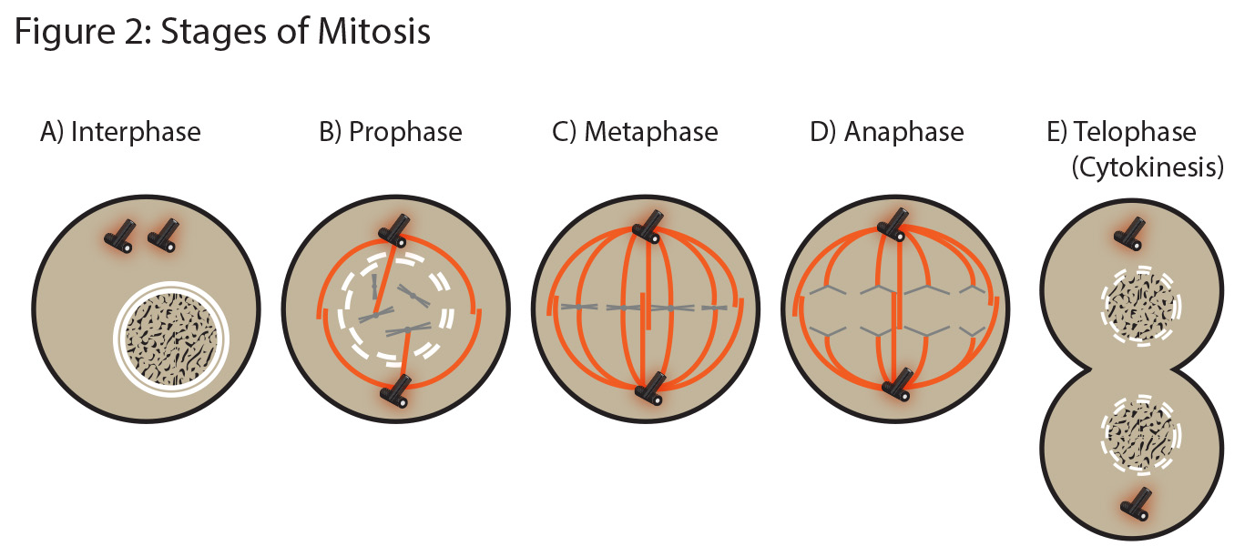









Interphase

* Chromosomes are copied (# doubles)
* Chromosomes appear as threadlike coils (chromatin) at the start, but each chromosome and its copy (sister chromosome) change to sister chromatids at end of this phase

Prophase

* Mitosis begins (cell begins to divide)
* Centrioles (or poles) appear and begin to move to opposite ends of cell
* Spindle fibers form between the poles

Metaphase

* Chromatids (or pairs of chromosomes) attach to the spindle fibers
* Chromosomes line up in center of cell

Anaphase

* Chromatids (or pairs of chromosomes) separate and begin to move to opposite ends of the cell

Telophase

* Two new nuclei form
* Cleavage furrow forms
* Chromosomes appear as chromatin (threads rather than rods)
* Mitosis ends

Cytokinesis

* Cell membrane pinches inward to create two daughter cells - each with its own nucleus with identical chromosomes